Jaypee Institute of Information Technology, Noida.

Subject: Unix Programming Lab

LAB TEST-2

SET-A

1. Create following directory structure

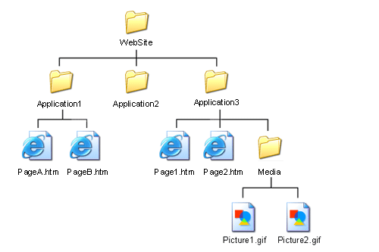

(a) If you are a root user, write a command to grand execute permission only for the owner of the file Page1.html?

(b ) Write a command to add execute permission for all users on file media.

(b) Remove write permission from directory media and application for user only.

(c) Move PageA.htm to directory Media

2. Write a script called ‘greetme’ that contains a comment section with your name and will do the following:

a. Ask the user's full name—first, last, and middle name

b. Greet the user by his or her first name.

c. Print the date and the time.

d. Print a calendar for this month.

e. Print the name of your machine.

f. Ask the user's year of birth and calculate his or her age (use expr).

3. Write a command to list name of files with "sac", followed by zero or other characters, then followed by "cas"

SET-B

1. Write a script called ‘greetme’ that contains a comment section with your name and will do the following:

1. Ask the user's full name—first, last, and middle name
2. Greet the user by his or her first name.
3. Print the date and the time.
4. Print a calendar for this month.
5. Print the number of user login

permissions on file textfile to read and write for the owner, read for the group, and nothing for everyone else?

**2.)** Create following directory structure

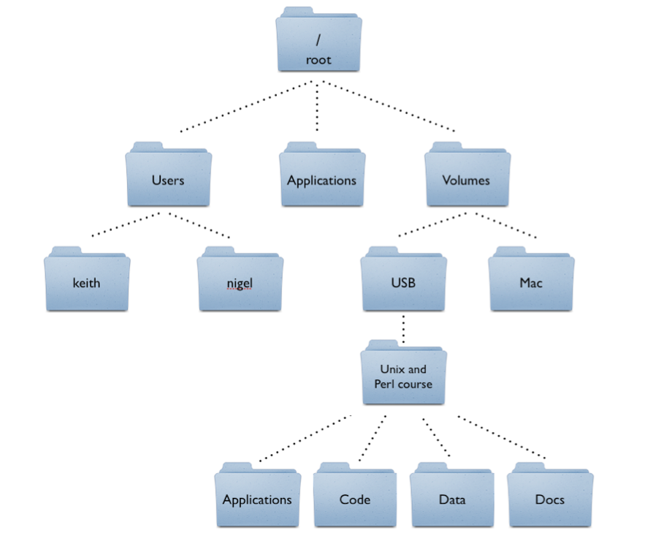

1. Write command to change the USB folder permission so that the owner cannot write(w) in the files of USB folder but can only read it.
2. Write a command to restrict the permission such that the user cannot search the directory USB
3. Write a command to give “execute” permission to the world for files “xyz.txt”
4. Write a single command to adds read(r) and write(w) permission to both user(u) and group(g) and revoke execute(x) permission from others(o) for the file abc.mp4.

3. Write a command to list name of files with "vir", followed by zero or other characters, then followed by "riv".